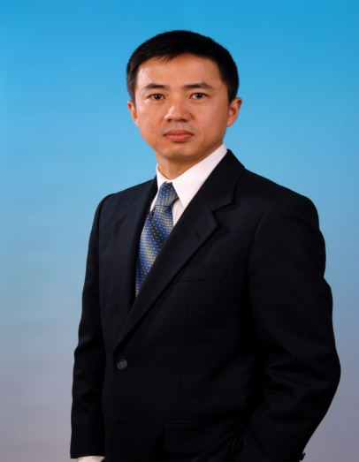

George Q Ling 凌 琦
Director
Business Development Group
Intel PRC Geo

George Ling is the Director of Business Development Group, Intel PRC Geo. He is responsible for Intel business relationship with enterprise customers, government entities and service providers in China. He began in Intel in 1994 as an Intel Architecture Manager. After that, he joined OEM sales team as a Lenovo account manager then led OEM sales team in South China for 4 years. George managed Intel Strategic Relations & Solution Marketing Team after his sales management position. Since 2002, George served in Intel Corporate Technology Group, an Intel research arm, for 3 years as Director of Strategic Technology Marketing. George’s most recent assignment was the Managing Director of Intel solution Service, North Asia, under Intel Software and Solutions Group.

George Ling graduated from Shanghai Jiaotong University with Bachelor’s degree in Automatic Control (EE) and Master’s degree in Computer Engineering. George also holds MBA degree from China Europe International Business School (CEIBS).

凌琦现任英特尔行业合作与解决方案部中国区总监，负责英特尔与中国企业用户，政府机构及服务供应商之间的业务合作。
凌琦于1994年加入英特尔公司，他曾在英特尔多个部门工作，担任市场营销和技术策略等相关管理职位，包括英特尔®解决方案服务北亚区总经理，英特尔中国软件拓展中心业务与市场发展部总监，英特尔中国区技术市场经理及英特尔中国OEM销售经理，英特尔架构经理等。
凌琦于1988年毕业于上海交通大学自动控制系，并于1991年在交大获得计算机工程硕士学位，他同时拥有中欧国际工商学院工商管理硕士学位。

